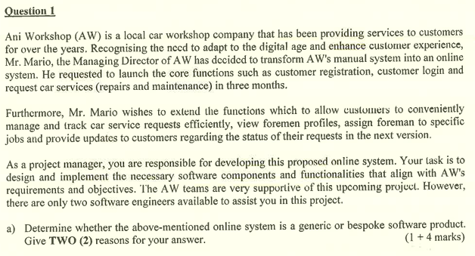

- Bespoke software product.

- The software product is designed for fulfilling the specific requirements and objectives for the specific customer, Ani Workshop only. Ani Workshop has requested for its own online system for providing car services to its customers.

- The Managing Director of AW, Mr. Mario also requested for functionalities extension which is designated for his car workshop company only. The system should allow customers to manage and track car service requests, view foreman profiles, assign foreman to specific jobs and updates to customers.

Keypoints:
- Launch core functions in 3 months
- Clear requirements
- Functionalities extension in future version
- Limited staff

Answer:
- Incremental model.

- Since Mr. Mario has requested for launching the core functions of the online system in 3 months which is short, the incremental model is able to quickly generate a functional software product for introducing the product into market early.

- Since the core requirements and objectives are clearly defined, an incremental model is suitable to be applied to produce software based on the specified requirements.

- Since Mr. Mario has planned to extend the functionalities of the online system in the future version; an incremental model can be applied because it can adapt to requirements changes or functionalities extension via iterative phases of design, development, testing and implementation. It can add on new features in future builds.

- Incremental model can be applied for this project because there are limited staff in the project team which is 2 software engineers only.

1.0 Usability
1.1 The system shall have low learning cost and time via applying consistent and standardized design layout in every possible system page.

2.0 Efficiency
2.1 The system shall process the car service requests within 5 seconds.

3.0 Delivery
3.1 The system shall be delivered and introduced into the market in 3 months.

4.0 Privacy
4.1 The system shall not disclose any personal information of users from the system database like account password.

- User guidance
  - The system should provide help facilities and meaningful feedback to users when users have made errors.
  - For example, the system should create a help button at the top right corner of the system user interface. Thus, the users can click on the help button to view the guidelines to submit requests for car services when they do not know how to request for car services.

- Consistency
  - The system should decide a standardized design layout for the whole system, then apply it to every possible page.
  - For example, the logout button is always located at the top right corner of every page, instead of located at a different position in every page. So, the users can easily recognize and remember the position of the logout button.

- Belongingness and love needs
  - The company should regularly conduct team building events which are open for all project team members. So, the team members can foster and strengthen the relationship and collaboration between each other via free communication.

- Self-esteem
  - The company should always respect all the project team members, provide constructive feedback to them and also publicly recognize their achievement in projects.

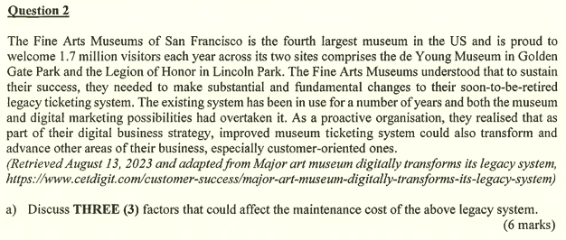

- Documentation structure
  - If the documentation of the legacy system is well-structured, the maintenance cost can be decreased as it is easy for software engineers to keep track of the system changes and specification. If not, the documentation structure has to be improved and it causes high maintenance cost.

- Age of the legacy system
  - The bigger the age of the legacy system, the larger the maintenance required. Thus, the maintenance cost will also get higher.

- Module independency
  - If the modules of the legacy system are highly independent with each other (low coupling and high cohesiveness), the maintenance cost will be low.

- Dependency to external environment changes
  - If the legacy system is highly dependent on external environment changes, the maintenance cost will be high because most of the system code has to be changed to adapt to the current environment changes.

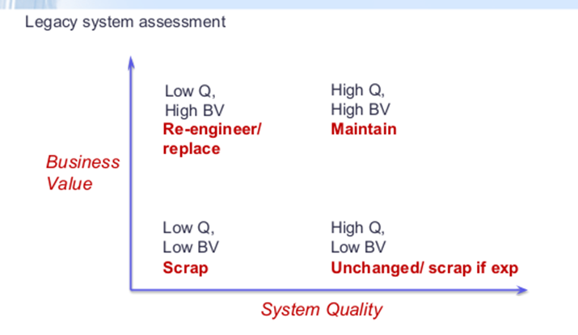
- High business value
  - The system helps companies to gain high profit on selling museum tickets to large numbers of visitors.
  - The system is currently implemented by two sites, the de Young Museum in Golden Gate Park and Legion of Honor in Lincoln Park.

- Low system quality
  - The system has been used for many years but there is no advancement made on the system and it causes digital marketing possibilities to overtake it.

- The technique used to maintain the legacy system is re-engineer.

- Layered model

- The legacy system has many modules or aspects like ticketing, digital marketing and customer service. Thus, the layered model can effectively modularize those modules into 3 layers which are presentation layer (manage user interaction), application layer (handle business logic) and data layer (manage data storage and accessing).

- Since the museum ticketing system tends to improve and extend its functionalities in the future, layered models can be applied to achieve high scalability as it supports incremental enhancements.

- The layered model can also provide high maintainability for the system. Thus, the system maintainer can easily fix parts of the system or add on features on the system without affecting the entire system or other module layers.

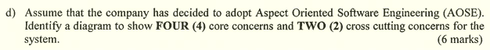

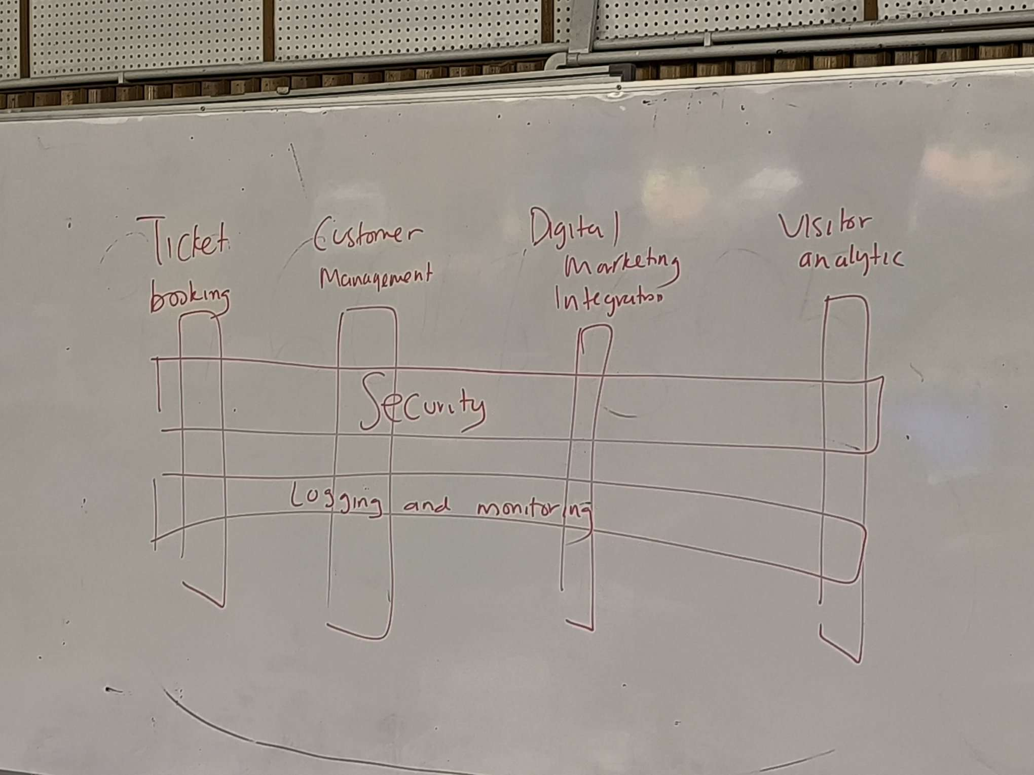

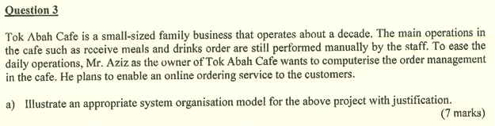

- Client-server model
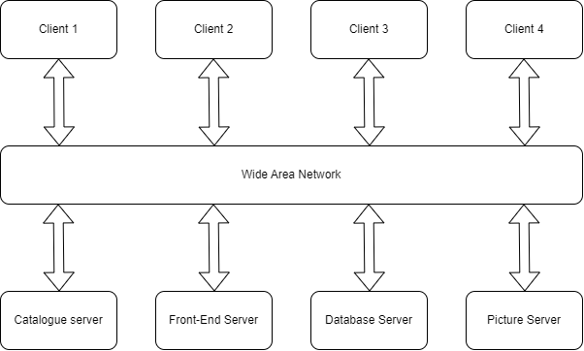

- Since Tok Abah Cafe is a small-sized family business which does not have high budget, it is suitable to use the client-server model in its system because it only requires low cost to use different low-moderate performance servers to process the system operation.

- The client-server model can also separate all the system tasks into multiple subtasks and distribute them to different servers to handle. This can effectively reduce the possibilities of overloaded situations on the system because all servers are sharing low workloads.

- Software testing strategy
  - It is a general approach to the testing process, instead of devising particular system or component tests.
  - For example, proactive testing. It refers to plan prevention steps before the problem happened. It can effectively prevent system bugs before the system is getting worse.

- Software testing stages
  - It represents different phases or levels at which testing is performed during the system development life cycle.
  - For example, unit testing. It tests individual components to ensure that they operate correctly. It requires test cases with conditions and options.

- Software testing technique
  - It refers to a specific strategy, method and approach used to design and execute test cases.
  - For example, white-box testing. It analyzes the code and uses the knowledge about the component structure to derive the test cases.

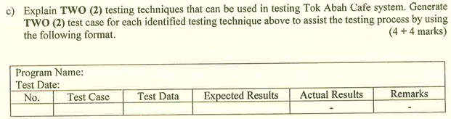

- White-box testing
  - It is a type of release testing.
  - It analyzes the code and uses the knowledge about component structure to derive test cases.

- Top-down testing
  - It is a type of system testing.
  - It starts the testing from the upper modules and works downwards.

Test Case
- No.: 1
- Test Case: Order food
- Test Data: Select the food item “Nasi Goreng”.
- Expected Results: The food item named “Nasi Goreng” is ordered.

- No.: 2
- Test Case: Order drinks
- Test Data: Select the drink item “Iced Cappuccino”.
- Expected Results: The drink item named “Iced Cappuccino” is ordered.

- Software testing can help developers to find out the existing system errors or bugs before deploying the software into production.

- Software testing can effectively check whether the developed system has fulfilled all the user and system requirements.

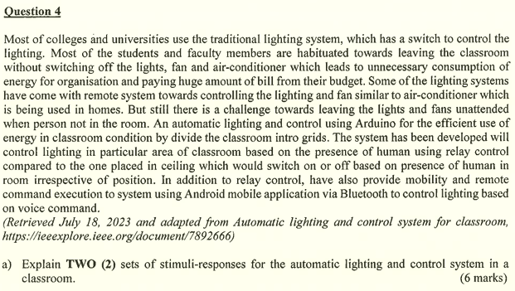

- Stimulus: Human is present within the detecting area of light control system
Response: The light will be automatically switched on.

- Stimulus: Human is out of the range of detecting area of light control system
Response: The light will be automatically switched off.

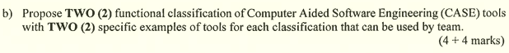

* Not cover in syllabus

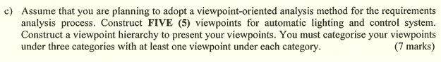

- Interactor viewpoints
  - College student
  - College staff

- Indirect viewpoints
  - Sales manager
  - Supplier

- Domain viewpoint
  - UI Standard

- Advantages
  - It can capture multiple viewpoints and requirements from different stakeholders to provide a comprehensive coverage.
  - It facilitates the communication between stakeholders and developers by focusing on a specific viewpoint.

- Disadvantages
  - It may be time-consuming as this method need to gather and analyze all the requirements from different viewpoints from existing stakeholders.
  - The collision may happen when different stakeholders with different viewpoints provide a conflicting requirements statement. It would be complicated to solve the conflicts.

